**Project Design Phase-II**

**Data Flow Diagram & User Stories**

|  |  |
| --- | --- |
| Date | 20-06-2025 |
| Team ID | LTVIP2025TMID20349 |
| Project Name | Resolve Now: Your Platform For Online Complaints |
| Maximum Marks | 4 Marks |

**Data Flow Diagrams:s**

A **Data Flow Diagram (DFD)** illustrates how data moves within the Resolve Now platform. It captures how user interact with the system, how information flows between different components, and where the data is stored.

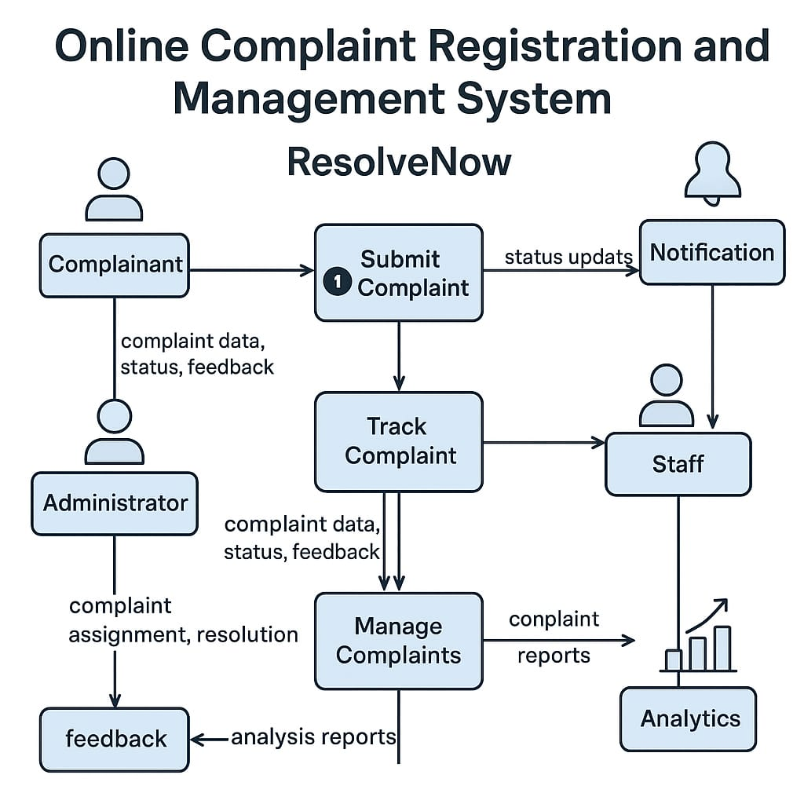

**User Story Table – Resolve Now**

|  |  |  |  |  |  |
| --- | --- | --- | --- | --- | --- |
| **User Type** | **Functional Requirement (Epic)** | **User Story / Task** | **Acceptance Criteria** | **Priority** | **Release** |
| **Client** | Complaint Submission   |  | | --- | |  |  |  | | --- | |  | | As a client, I can post a Complaint. | Complaint appears on the agent's dashboard. | High | Sprint-1 |
| **Agent** | Complaint Handling | |  | | --- | | As an agent, I will handle the assigned complaints. | | Complaint is marked as assigned and updated by the agent. | High | Sprint-1 |
| **User** | Real-time Communication | As a user, I can chat with the agent assigned to my complaint in real-time. | Messages are sent/received instantly; chat history is visible. | Medium | Sprint-2 |
| **Client** | Complaint Processing Confirmation | As a client, I can view confirmation once my complaint is submitted. | Client sees a confirmation message and complaint ID. | High | Sprint-2 |
| **Admin** | Complaint & User Moderation | As an admin, I can review all user complaints and take action if needed. | Complaints and user actions are visible; admin can block users. | High | Sprint-1 |